VCU School of Medicine Funding Guide

The VCU School of Medicine has three main fund sources that we utilize for day to day student activities. These sources are derived from a combination of our student fees and outside contributions. These funds are as follows: the MSG Fund, the Society Fund, and the Dean’s Fund.

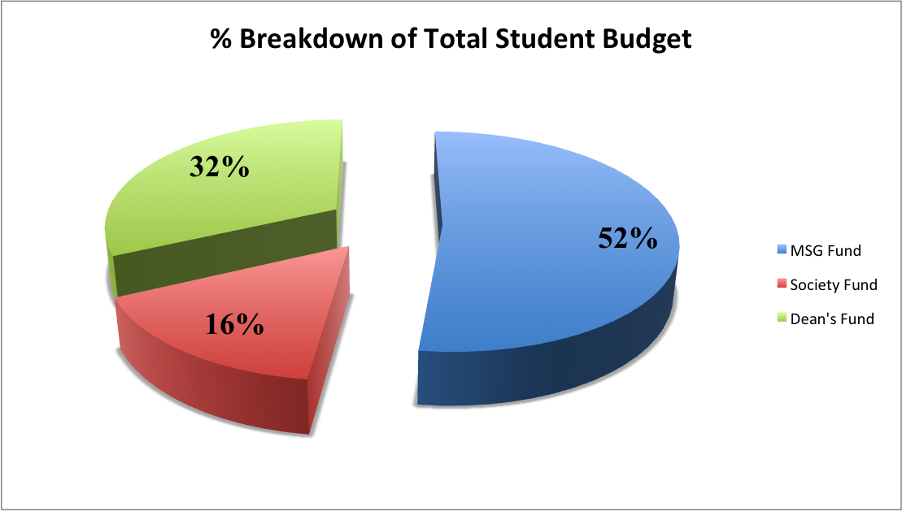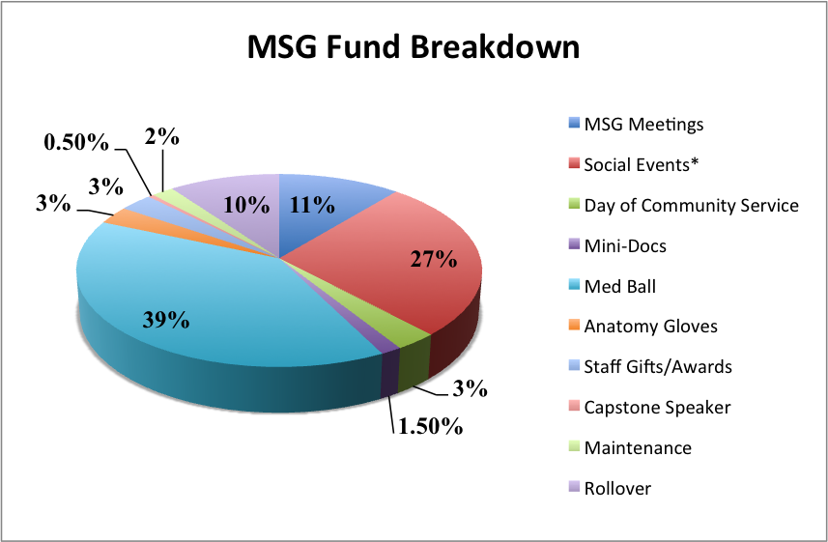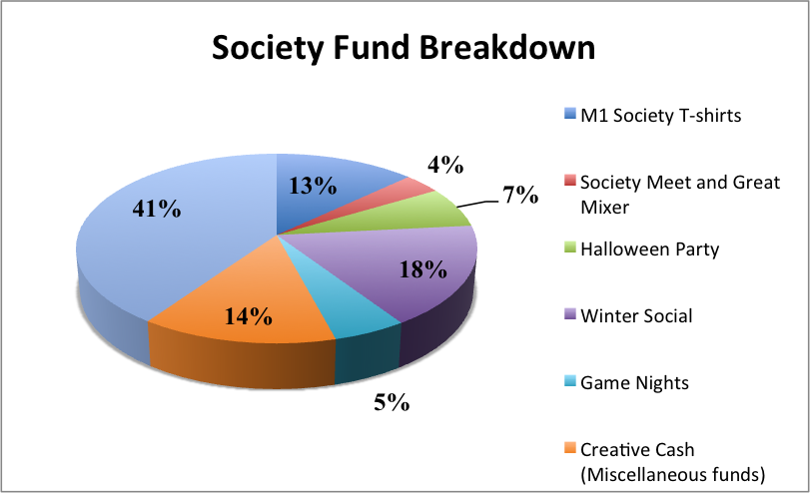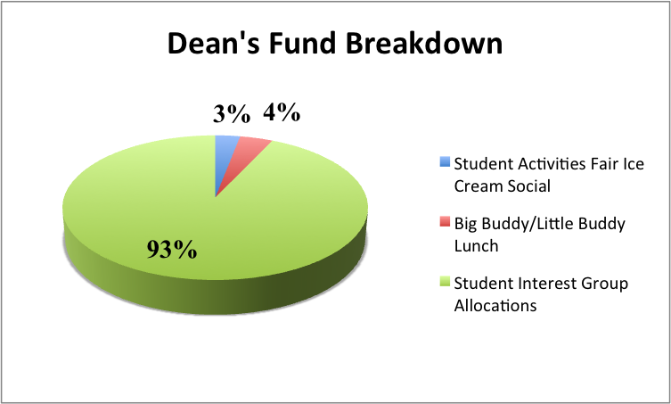

The MSG Fund: The MSG fund is supplied by part of the student activities fee. The activities fee is paid by each full-time member of the School of Medicine student body, and the budgets are then turned over to the Medical Student Government on a yearly base. Therefore, MSG’s primary goal is to promote camaraderie and greater enjoyment among all four classes of medical students, through initiatives and activities centered on achieving this goal. The Treasurer of MSG is responsible for preparing an annual budget that will be presented at the first MSG meeting of the year, in which a vote will take place to approve the initial predicted allocations. Funds go to various student life initiatives, social events (Medicine Ball, Cheese n’ Chat, etc), community service events (DOCS, etc), and much more. The Dean’s Fund (see below for more information) is intended to fund student interest groups and help promote their activities. Therefore, LL and SIG activities should be funded by the Dean’s Fund, and only when Dean’s Fund money has been depleted will MSG start taking requests for funding. Another option for SIG’s to get funding is the SGA fund (discussed below). However, if a SIG would like to partner with MSG because their event will center around achieving MSG’s broader goal of involving all four years of medical school classes, then MSG will consider taking requests for co-sponsorship. Instructions to do so are below:

- Student organizations or individual medical students requesting funds from the Medical Student Government shall submit a written request to include an itemized budget and statement of intended use (a MSG Funding Application) to the Medical Student Government Treasurer seven days prior to the meeting at which the appropriation is to be discussed.
- Medical student organizations must be registered with the School of Medicine’s Office of Student Activities in order to submit appropriations requests.
- Medical student organizations must be registered with Virginia Commonwealth University MyORGS.
- Medical student organizations or individual medical students requesting appropriations must present their budget at the next Medical Student Government meeting in 2 minutes.
- Requests for appropriations must be approved by a simple majority of a quorum of the voting members of the Medical Student Government Executive Council, unless the request is retrospective in nature. If the request is retrospective, the appropriation must be approved by a two-thirds majority of a quorum of the voting members of the Medical Student Government.
- All organizations or individuals receiving funds appropriated from Medical Student Government Funds shall be responsible to the Medical Student Government Treasurer in accounting for their use, and must abide by the same regulations as those set forth by Virginia Commonwealth University.
- Organizations will be informed of approved/unapproved appropriations via the meeting minutes.

The Society Fund: The Society Fund is an independent fund given to us by the Dean used solely for Society sponsored events/purchases. These include: M1 society t-shirts, the society meet and greet, the annual halloween party, the society winter socials, society valentines, and most importantly, the Strauss Cup. SIG’s and other groups may partner with Societies to host events in order to “access” this money, but otherwise, they are unable to receive funding from Societies for their own personal use. The money in this account does not roll-over year to year, so it is in our interest to use up this fund completely by the end of every calendar school year.

The Dean’s Fund: The Dean’s Fund is an independent fund gifted to us by the Dean intended to fund student interest groups. Therefore, LL and SIG activities should be funded by the Dean’s Fund, and only when Dean’s Fund money has completely run out will MSG start taking requests for funding. While the largest allocation goes to student interest groups, the Dean’s Fund also sponsors the Student Activities Fair Ice Cream Social as well as the Big Buddy/Little Buddy Lunch. Primary allocation of interest group funds occurs at December reallocation and April allocation. Individual requests, however, may be made throughout the year (in between April Meeting and December reallocation) for groups that have depleted their funding for the year. These requests should be accompanied by specific future events and cost estimates. The Dean’s Fund chairs may grant the SIG more funds immediately or hold off until December or April in order to ensure the ~70 established groups have an equal chance at a slice of the pie, rather than encouraging groups to spend faster to obtain more.

December Reallocation: In mid-November, an email will be sent to all SIG’s containing a comprehensive form to take a look at their remaining Dean’s Fund balance. If they are low and have more activities planned, they can request more money at this point. If they have funds sitting around with no intended use, the Dean’s Fund chairs reserve the right to redistribute their funds to other active groups unless they propose future use within the next semester.

January SIG Orientation: In January, the Dean's Fund chairs partner with MSG to educate the new SIG leaders on funding and reimbursement.

April Allocation: In an effort to decrease conflicts with both M1 and M2 schedules, the April allocation is held at the end of the year. It represents the main allocation of the year.
All SIG’s will receive an email with information on Dean’s Fund meeting date, time slots, and location at least three weeks beforehand. This email will have two attachments: 1. A Google excel document for groups to sign up to meet for a 10 minute time slot. 2. A Dean’s Fund request form, which groups should have filled out prior to their 10 minute time slot to be brought in hard copy. After all groups have met, the entire Dean’s Fund committee will meet to discuss allocations appropriately. Established groups will receive funding for the next year based on: 1) prior year funding, 2) organization activity in the prior year, 3) next year’s plans and their requested amount.

In the event a newly formed organization is made, (a) ensure you are registered with the curriculum office, (b) fill out a funding form, (c)$200 is generally allocated to the new group from “unallocated.” A new group should not, however, spend this money until the funds have been verified by one or both of the Dean’s Fund chairs.

FAQ:
- For workshops, Dean’s Fund can cover supply costs, such as suture and chicken, but cannot pay for food or any items for the students.
- Generally, Dean’s Fund is not for book clubs, yoga, gift cards, "non-academic" activities.
- Funding allocation for lunch lectures is roughly $3-4 per person. Funding generally occurs retrospectively, so please verify that your purchases are approved so that you may be reimbursed.
- The current Dean’s Fund chairs can be reached at DeansFundVCU@gmail.com

Other Source of funding: SGA

As we transition from two separate SGA organizations governing the two individual VCU campuses to a single large SGA, the

FALL 2017: To receive SGA funding all student organizations must register online at http://www.usca.vcu.edu (via the VCU RamsConnect system). After registering as a student organizations at VCU, Student organizations must then fill out a funding request form found at: http://sga.vcu.edu/funding-requests/
Conditions for funding:
  - all MCV students must be able to participate in the event, regardless of organization/school affiliation
  - Requests must be submitted a month prior to the event
  - Can request funding for any programming (maximum of $2000)

For Fall 2017, funding applications should be filled out and submitted to the Assistant Treasurer by 5 PM two Mondays before each Graduate and Professional Student Senate meeting. Those deadlines are:
- August 21, 2017
- September 11, 2017
- October 9, 2017
- November 6, 2017
- November 27, 2017
All requests will be approved or denied by the Appropriations Board after submission, but by the date of the Graduate and Professional Student Senate meeting. Your organization may be asked to give a brief presentation on the request to the Appropriations Board.

SPRING 2018: A new funding model will begin that will recognize three funding periods: Fall, Spring, and Summer. Student organizations will be asked to submit budgets for each funding period. The Appropriations Board will approve or deny the budgets by the start of the funding period. The deadline for the spring funding period is October 1, 2017.

An example of the budget that must be submitted can be found here: http://sga.vcu.edu/quick-links/

Submitted budgets may encompass items that fall under one of three categories: programming, travel, and operational funds.
- Programming funds may be used for events, including fundraising events; facility rentals; skilled and contracted services; and food and supplies.
- Travel funds may be used to send members to conferences, retreats, and other activities.
- Operational funds may be used by an organization for regularly used equipment; office supplies; publicity and marketing (for the organization, not a specific program); and awards and prizes for organization members.

SUMMER 2019: Student organizations will have to submit budgets by March 1.

