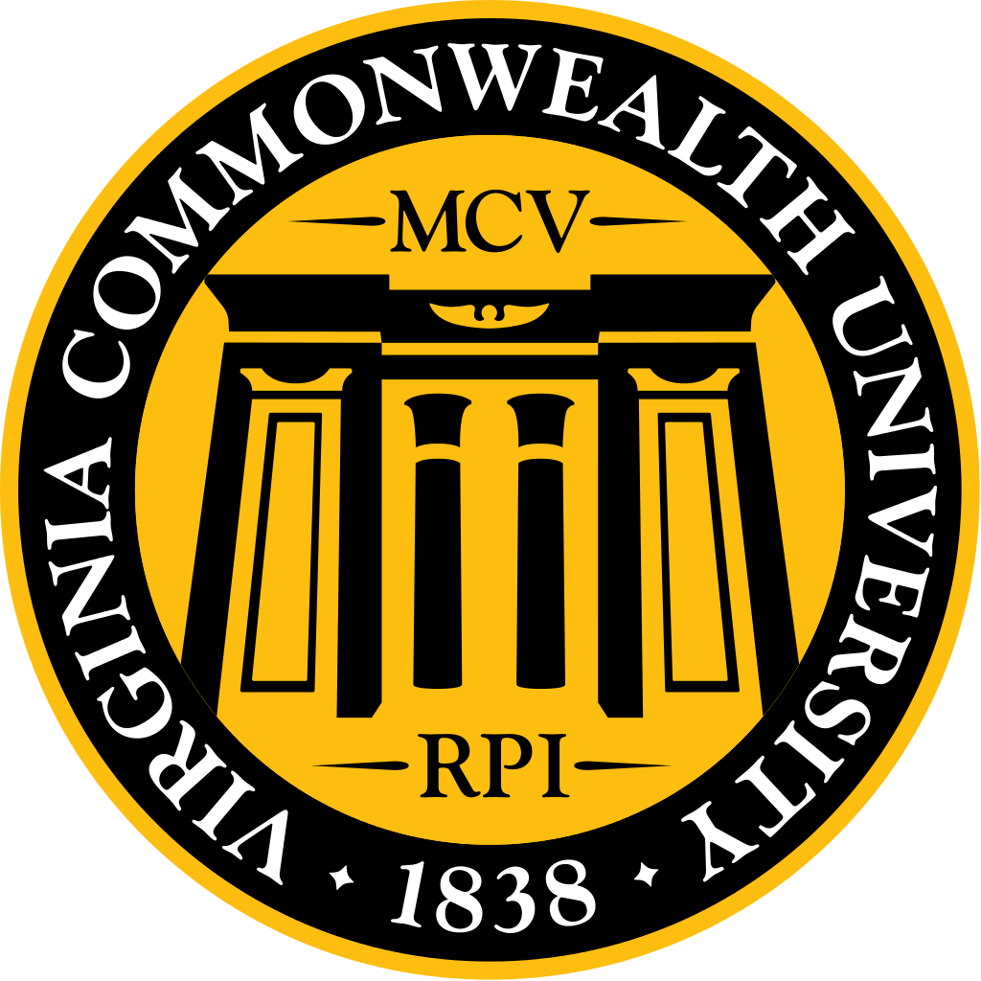
November 2016 MSG Agenda
Highlights
- VCU marketing, trademarks and licensing talked to us about the new brand and asked for feedback as they create new organization guidelines.
  - You may use the seal + VCU in the official font. You cannot use just the seal or use VCU in any design that you create. You may create your own design, but it cannot lock up with the VCU official logo. Check out the website: https://www.identity.vcu.edu/
  - Refreshed brand mark coming soon.
  - They are creating a new seal that could be used on the white coat, essentially a VCU academic spirit mark. If you have questions or would like to be involved email identity@vcu.edu.
  - Send designs to Christy Rabil (crabil@vcu.edu) to get approval and if it is not approved she will tell you why. You must use a licensed vendor and they can send designs to Christy Rabil for approval as well.
- Canned food drive is going on, please bring cans to help your society win!
- Medicine ball is December 2nd at the Omni, please RSVP!
- If you would like to plan a spring event please talk to MSG about it so that they are not scattered!
- Look for the LCME survey coming out soon and encourage your classmates to fill it out! This survey is the last element in order for our school to stay accredited.
  - Waiting to find out if MSG may add an incentive
- M4 Dean’s letter is being restructured.
Outline:
1. Welcome & Introductions
2. Speaker/new business (5-8 min)
- Ms. Kendal Plageman – VCU Assistant Dean of Student Affairs
- VCU Marketing, Trademarks, & Licensing - Chrisy Rabil, Tom Klug & James Morrisard

1. Welcome & Introductions
2. Speaker/new business (5-8 min)
- Ms. Kendal Plageman – VCU Assistant Dean of Student Affairs
- VCU Marketing, Trademarks, & Licensing - Chrisy Rabil, Tom Klug & James Morrisard
  - Why this matters? We use to get the majority of our money from apparel fundraisers, but there have been changes to the brand that have made this difficult.
  - We are changing organization guidelines and would like feedback on what you want.
  - What we are allowed:
    - Seal + VCU School of medicine.
    - You cannot use “VCUMED” because that is a new logo that is not approved.
    - You cannot use “MCV” because this is a retired logo.
    - VCU if it is academic and VCU Health if it is clinical.
      - Launched VCU Health brand about a year ago, including everything clinical and all health science schools. Met with all the schools and they still want VCU when it is academic.
      - We are trying to create an endorsement mark to maintain a bridge between VCU Health and VCU.
    - We are aware that things have been used that were not approved, but we are not holding anyone responsible. We know a lot has changed and that it is confusing. We are trying to create clarity. We are trying to help.
  - Q: Can we have the patch back on our sleeve?
    - University relations knows that a seal is needed but cant get to it yet.
    - We are creating a new seal that will be ready in about a year for the sleeve.
      - This new seal would be an academic version of the spirit mark. Essentially a spirit mark for the VCU Health
  - Q: You mentioned a patch logo, who is working on it and can we help?
    - Email identity@vcu.edu
    - They have not started.
    - Designing an academic spirit mark that we could use. Not specifically for us.
  - Q: Would they ask for feedback once it is done?
    - We do not know, you would have to ask.
  - Q: MCV? Can we use it?
    - No. MCV is retired and it would not be approved.
  - Q: How can we use the Seal and VCU School of Medicine?
    - Can have the seal+VCU in one place and then School of Medicine somewhere else. You cannot separate any of the elements of the official logo.
    - You do not need to use VCU Health
    - We are about to release the refreshed brand and it will be available online.
  - Q: How do I get approval?
    - Send it to Christy Rabil and then she will approve or let you know if it is approved. If it is not approved she will tell you what you need to change in order to get approval.
    - Look on the identity site to see what is approved.
    - You can put whatever you want on the tshirt it just can’t lock up with the logo.
    - You can make your own design as long as you don’t use the logo or add or take pieces of the logo. You may not create a new logo.
  - Q: What happens if you create something that was not approved?
    - You would be misrepresenting the school and you could face legal repercussions if you use a non-approved logo or design.
  - Q: So there were no policies in place before, and now you are creating guidelines? Who is it that is creating these new guidelines?
    - Dr. Rodgriguez and Clink as well as University relations.
    - It is a mess right now, but working to create guidelines for what groups can use.
    - Plan is to have them by spring.
    - The student registration guidelines are on hold now and these guidelines would be tied to that.
    - MSG trademark would be different and more flexible than guidelines for each individual class.
    - Strategy marketing manages VCU Health.
  - Q: Where can we order from?
    - You must use an approved vendor.
    - Royalties go to student scholarships.
    - Vendor fair on this campus in March. Inviting about 15 vendors that are great for us and easy to order from. Will send more info closer to the date.
  - Q: Where do we go for more information?
    - There is a website!
    - Brand.vcuhealth.org is uptodate. The VCU one is not yet updated.
    - We would like you to use VCU Health if it is clinical, but the health science schools will probably have an either or deal. With clinical vs. academic we understand that there are grey areas.

Medical Student Athletic Community
Class Updates (2 min per class)
- Class of 2017 – going on interviews!
- Class of 2018 – in the hospital!
  - Class of 2018 at INOVA:
    - Chugging along M3 clerkships. Last Wednesday INOVA announced ending partnership. Last class that will complete M3 core clerkships at INOVA is the class that is applying now and then UVA will rotate at inova. All
    - Building a new translational medicine building, which will have a lot of baby genetic testing and cancer research. UVA wanted to get involved. 128 million dollars. Part of the deal was that they asked for their students. Unsure where our students will go.
    - Will still be able to still do M4 clerkships at INOVA. That aspect of the relationship will not change. VCU students just wont do core M3 clerkships at INVOA.
- Class of 2019 - none
- Class of 2020 – just finished I&I. Looking into discount for pathoma and UWROLD.
- Medical Student Athletic Community (MSAC) – 3pm this Saturday. SGA funded so everyone is welcome! Just need to bring canned food to play. Tshirts and prizes for the winner!

MSG Updates (5 min per officer)
- Treasurer
- MSG Budget is uptodate
  - If you use MSG money, please send the amount/pic of the receipt to Suraj
- Funding document attached to the Scoop has been updated
  - If you need money, look on that document.
- Waiting to find out if MSG may add an incentive to the LCME survey
  - Initially talked to Woleben about this, but now there is no money. Dr. D said she will put $200 of her own money. Trying to figure out how to add incentive.
- VP of Social
- Medicine Ball:
- Date: Friday December 2nd
- Time: 8:00 PM – Midnight
- RSVP has been sent out – over 200 people responded!
- Two musical acts: live band (TJ’s band) and DJ.
- Food, dessert, cash bar, and photo booth!
- Parking at the venue is $3 for their parking structure
- There is also a DD bus that will run from the hotel to the middle of the fan continuously from 10:30 to midnight.
  - Looking into if the bus can go a little past midnight.
- VP of Community Service
- Thanksgiving Feed Drive – 11/01-11/15 *has been extended!
  - Spread the word and get your class involved!
- November mini-DOCS – 11/12 at Lewis Ginter Botanical Garden
  - Not a lot of participation. Please encourage people to sign up!
- Clothing Drive
  - Starts 12/5, Amanda will start and then it will be organized by Ian Lovern
- VP of Societies
- Halloween Party Recap
  - Shorter length, especially since painting pumkins instead of carving. More food.
- Movember fundraiser
  - Happening. M1s and M2s are participating, at least 15. Society leaders are working on advertising. M3s & M4s unable to participate due to clerkships.
- Society Winter Social
  - Dates have been set. Will be help at society leaders’ houses or other locations. Look out for emails for dates!
- Strauss Cup
  - Byrd Park.
  - Look into another park. Unable to book park yet.
- Other spring events
  - Organized by the M1s.
  - Should have money for a study break.
  - Please talk to MSG about these events so not as scattered.
- Talked to Dr. Woleben about the society leaders contributing to deans letter.
  - They are re structuring the Dean’s letter. May have an area where the society leaders can contribute.
  - Some ambiguity as to what the Society leaders will do for us.
- VP of Student Life
- Mistreatment feedback:
  - There are focus groups going on, aiming to identify possible pitfalls in the reporting system and how to improve the learning culture at VCU. Encourage students to participate!
  - If you get invited please go, they are great. You do not have to feel mistreated in order to participate. These focus groups were created for them to understand the students’ perspective; they really want to hear your honest feedback.
  - No M1s have signed up, which was surprising.
  - The school is taking this seriously and trying to do something about it so please participate.
  - This is a one time thing. They will come back with suggestions for the School of Medicine.
- VP of Publications
- Student Interest Group Awards – working on collecting feedback
- VP of Curriculum
- Look for the LCME survey coming out soon and encourage your classmates to fill it out. It’s significantly shorter than the original, so it shouldn’t take up too much of your time. The class with the highest percentage of participants will receive money to use toward graduation or whatever else they choose.
  - Will keep you posted! Bug everyone about it and encourage people to do it!
  - Required to get 80% participation from each class.
- Secretary
- Dean’s Luncheon – October 27th
- Next MSG Meeting – November 30th, MMEC 3-101 at 6:30 PM
- Spring dates – January 17th, February 15th, March 13th, April 12th, May 4th
- MSG rep to SGA
- Funding is gone – meetings continuing
- Winterball – January 28th
- President
- Facebook – Virginia Physiology
  - Who are they? Is this an administrator? We may not want them in our facebook groups.
- Class of 2019 MSG Officers – Update MSG Drive with plans for spring
- Proxy Search
- VP of Student Life (Tim)
- VP of Community Service (Amanda)
- VP of Social (Omar)
- VP of Societies (Kathryn)
- MSG SGA Representative (Yousef)
- Dean’s Luncheon – November 29th

Attendance
Officer | Attendance/Proxy
MEDICAL STUDENT GOVERNMENT
President – Katie Pumphrey
Secretary – Perrin Downing
Treasurer – Suraj Mishra
VP of Student Life – Tim Wills
VP of Societies – Kathryn Gouthro
VP of Community Service – Amanda Williams
VP of Publications – Rajbir Chaggar
VP of Curriculum - Jill Safflinger
MSG Rep to SGA – Yousef Fazel
VP of Social Affairs – Omar Protzuk
CLASS OF 2017
President – Yeri Park
Vice President – Perrin Downing
Vice President – Karen Brown
Treasurer – Sarah Berg
Secretary – Fairouz Chibane
INOVA VP – Neil Patel
INOVA Secretary/Treasurer – Sri Karuturi
CLASS OF 2018
President – Trammell Cox
Vice President – Suraj Mishra
Vice President – Ron Rosenberg
Treasurer – Timothy Nobbee
Secretary – Soumya Murag
INOVA VP – Blair Saunders
INOVA Secretary/Treasurer – Ashley Rogers
CLASS OF 2019
President – Julie Park
Vice President – TJ Phillips
Vice President – Omar Protzuk
Treasurer – Jonathan Korpon
Secretary – Russel Dinh
CLASS OF 2020
President -
Vice President -
Vice President -
Treasurer -
Secretary -

