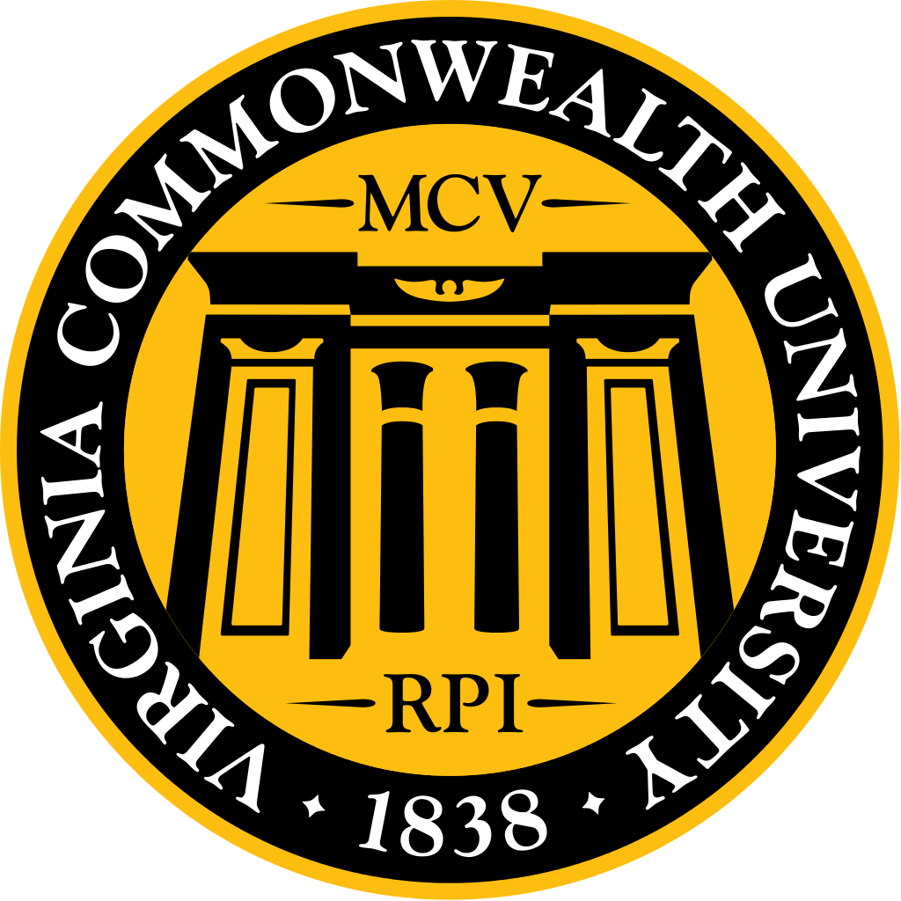
February 2017 MSG Meeting
Dr. Buckley
Wednesday, February 15th, 2017

Highlights
February MSG meeting was dedicated to meeting and learning more about Dean Buckley
- Privileged to be here and that so many people turned out
- Dean Buckley is in his 5th week and in the learning phase. Doing a lot of listening.
- For almost 7 years was dean at the Medical College of Georgia in Augusta and before that was chair of the Psychiatry program. Before moving to Georgia he was in Cleveland, Ohio.
- After 16 years in Augusta, we felt we were ready to come somewhere else. This job cropped up at the right time. This school has a fantastic reputation and trains great doctors. The quality of research coming out of here is great and the chairs are really strong. The symbiosis of this university and the city is quite remarkable. I’m excited be here, being Dean is a fantastic opportunity.
- You may see Dr. Buckley in the fan walking with his wife and 2 great Danes.
- Currently developing his SWOT analysis (strength, weakness, opportunity, threat). It is still in the works, but there are a few things to do. We need to stay accredited and continue to work on the new curriculum. There are financial aid issues and we need to work on scholarships.
- Looking forward to being highly innovative. Expect that the medical school will have state of the art content and delivery.
- We have the ability to offer a broader menu of degrees in addition to the MD degree.
- We have a mistreatment rate of 45%, which is very high. You’re entitled to great training, but in an entirely supportive of you environment. We need to figure out what that means and put things in place to fix that.
- In Georgia they were building a leadership program. Dr. Buckley thinks some aspects of that will travel well here.
- This school has a fabulous simulation center and its use has been moving along pretty well. But, there are more commercial things that can be done with that to bring in more opportunities.
- There are probably other things to work on, but have to be careful and respect a new place and see what’s working and not working.
- Would like to have a lot of contact with medical students. You’re fun to interact with. It is not a chore and I expect to meet many of you. If you feel I’m distant, you know where I am. I was employed to serve you. And if I’m not serving you, you should ask. I look forward to interacting with you and please consider that "my door is always open".
- VCU is doing a strategic plan. MSG is already actively speaking with them. If you like this stuff and want to be involved, please speak to us (MSG).

OUTLINE
Intro
About Dr. Buckley
Q: What do you like to do for fun?
Vision for the School
Financial Aid / Scholarships
INOVA
Q: Has there been any talk of a new satellite campus?
Vision
Q: Is there anything that Georgia did that was particularly good that could be adopted here?
Q: What sort of role will you have with the medical studnets? What is the role you hope to have with medical students?
Q: How is VCU working to increase alumni engagement?
UVA SOM tuition is approximately $10,000 more than VCU SOM per year ($43,828 vs $32,453), but VCU medical students graduate with approximately $34,000 more in debt ($125,094 vs $159,288). What is VCU doing to decrease student debt and increase scholarship opportunities?
Physicians are the fastest growing group of healthcare leaders (ex. CEO, COO, etc.). How are we ensuring that VCU SOM graduates are ready to be leaders in healthcare?
For the class graduation gift, other schools have the graduating class provide a scholarship. Do you think that we should encourage VCU SOM to do this?
What are your thoughts on VCU ending our partnership with the INOVA health system (ie. the reduction of students per class, etc.)? Any comments on future campus opportunities?
Closing
Addendum

INTRO
Katie Pumphrey, MSG President: Welcome to MSG! Today we are not having our standard MSG formatted meeting, because we have chosen to dedicate it to Dr. Buckley. Introduces Dr. Buckley.

Dr. Peter Buckley
VCU School of Medicine Dean & VCU Health System Executive Vice President for Medical Affairs
It is a privilege to be here and that so many people turned out.
First, I will tell you about my self, then about the school, and then any specific questions.
This is now my 5th week as your Dean. I’m not going to ask how I’m doing. There are layers of understanding. I’m in the learning phase. The dilemma with it is that they don’t give you an observership. You don’t get to watch and shadow for a few months and then take over when you’re ready. You have to learn the job while doing it.
About Dr. Buckley
This is my second time around. For almost 7 years I was dean at the Medical College of Georgia in Augusta. Before that I was chairman of psychiatry. I had a great experience there. When I took over the previous chair had been incarcerated for research fraud. So you can imagine how rock bottom. Good experience turning around the department.
Before that I was in Cleveland, Ohio and fortunate to rise through the ranks to be vice chair. Previously I was medical director of one then two then three practices. They weren’t in the best shape and I ended up turning those around, eventually.
I did my training in Ireland. I did a fellowship in schizophrenia. Today I actually spoke to my mentor. I had the chance to come to America for research. My wife and I moved to Cleveland without knowing anything about it, except that it was a great program. It was very exciting being there.
In Georgia I helped turn around the mental health program. There was a scandal, similar to the one going on now, so I worked to turn it around.
As dean I got to look over and help turn around the other campuses. Medical College of Georgia is the 9th largest medical student. The main campus in Augusta. There is an associated 4 year program in Athens as well as 3rd and 4th year rural campus in Albany, another in Rome and another in Savanna. They just crystalized another in Atlanta that will serve as another campus.
Like you, we had a LCME visit last year, and like you we did very well. Like you, we had a new building designed for the new curriculum. Received a 10 million dollar gift from an alumnus. We actually looked at this building (MMEC) to mirror. In his (the Alumni) will he gave 66 million dollars to the Medical College of Georgia, which will go to 48 medical student scholarships and 10 endowed chairs. Someone else will build what will be a fantastic leadership. I was kind of the last man standing. I ended up being CEO of the hospital for 2 years. That is a long time to do 2 jobs. It was a fantastic experience. As a result of all of that, and 16 years in Augusta, we felt we were ready to come somewhere else.
This job cropped up at the right time. The school has a fantastic reputation and trains great doctors. You all will be great doctors. The quality of research coming out of here is great and the chairs are really strong. As you know better than I, the symbiosis of this university and the city of Richmond and the commonwealth of Virginia is quite remarkable. The pride, you can see it from outside, but coming here the pride in this city of the university is fantastic. I’m pretty excited to come here. It is a fantastic opportunity. Doing this job a second time. I have learned a lot of things in Augusta, particularly philanthropy.
I’ve been married 29 years. She came from Ireland with me. We have two sons, John 23yo and Bryan 21yo, both in Athens, Georgia. They stayed, but we brought 2 proxy children, 2 enormous great Danes now living in a small house.
Any questions? Or I can move onto vision.
Q: What do you like to do for fun?
I like walking the dogs. We bought a house on park avenue in the fan. We thought we could only walk around the block, but have discovered parks. We recently bought leashes for the dogs that are like an electric fence and GPS that are great. Enjoy going out. You cant move to Richmond and be on a diet. I used to go to the lake a lot. We had an 11yo boat named “1 more year”, each year wondered if it would make it another. There is probably opportunity here. With this job I am fortunate to continue to be involved in federally funded research on schizophrenia and rheumatoid arthritis drugs, but when you combine this job there isn’t a ton of time. After a days work there are other events, so what time I have off tends to be family time and I like to travel, but that’s curtailed. So, a lot of walks.
I do have a funny voice I tried to culture-ate, but I failed. It’s no longer Irish, but not quite American.
Vision for the School
I’m now on my 5th week. It is a juggling act of learning the university and the school and at the same time signing letters, hiring people and keeping the momentum of the school. Another thing you should be aware of, here, in addition to being the dean of the medical school I am also executive vice president of medical affairs, overseeing the 600 physician-faculty group practices of the academic health sciences center. The job is academic, teaching, research, and clinical. It does administration oversight and role in education (though easy with people like Chris) and then oversees research of the school. I’ve been listening a lot. Having a lot of group talks as well as one on one. What I didn’t bring, I developed a SWOT analysis. It is a way of getting your arms around an issue. SWO is strength, weakness, opportunity, and threat. A way of getting around, but also starting the journey. Getting a vision and making a strategic plan. As I was privileged to look at this position I started to put together a SWOT analysis and listening to others. Last week I presented it to the executive committee of all the academic affairs and a number of other individuals and got feedback. It’s yours, but you want it to be the schools. When I brought it to Dr. Rao, the president, he asked what am I going to do. Which is a reasonable question. It will be very helpful to get feedback, which will help with the vision of the school and university. You can’t go off the ranch, it doesn’t work well to be non-congruent with the university.
It’s a great time to do it. “Quest for Distinction” is the university’s strategic plan. Out of that will come another that has already kind of begun. What we are trying to do should curtail nicely and help us to see a direction. Sounds wonderful, but should still ask me what my vision is.
A number of things we need to do.
We need to keep accreditation. You’re all at amiable positions, different stages, and you should be proud of where you are, but as you graduate you should want us to stay accredited. It’s gone through its first 4 years of new curriculum and as you know there are financial aid issues. Taking care of accreditation is very important. The worst thing to happen would be to have been flawless, because then you’re not going to get better. Don’t want to be on the wrecks, but want to have things to make better.
We need to look at the curriculum. Looking at C3 it looks like it’s off to a great start. There are some complexities that could be flattened out. As you graduate we need to get a pressure check of how it went. The next site visit isn’t until 2024. This gives us opportunity to be highly innovative. When a site visit is coming up you want to have things running smoothly. Medical education is not stagnant, but very dynamic. Delivery and technology and the interface between them and the classroom. Looking forward to being highly innovative. Looking at the details of what innovations and how they’re phased in. Expect that the medical school will have state of the art content and delivery.
Financial Aid / Scholarships
We have got to work on scholarships. You always have to work on scholarship. I was surprised, I didn’t realize that there was a scholarship discrepancy of that magnitude between UVA and VCU. This is partly why I told you about the 66 million dollar gift to MCG. I appreciate the impact and the enormity of debt and its impact on family and career. That’s going to be part of my job. Not singularly, but a nice part of our school, is the good organized philanthropic structure. Already this year over 6 mil and over 39 mil last year. That profile has gone up. There was a capital campaign. 174 mil out of the 300 mil expectation. So your needs are in the mix already. So that’s another priority that we need to work on and its really a joy to work on since it makes a big difference.
INOVA
I don’t understand the decision, I wasn’t here, but it is irreversible. We will be phasing out in a careful and respectful manner, that ensures that until the day campuses close that INOVA students get the same high quality training that you get here.
Q: Has there been any talk of a new satellite campus?
Great question. You probably know more than I do. This decision was announced end of November. And, if it came as a shock to you, it came as a shock to many and especially me. I was excited about a satellite. I told you about the many campuses at Medical College of Georgia. I don’t want to be disrespectful. It is just a fact, a decision was made and we need to work with it. I’m not saying it was good or bad, but it was made.
It got made and announced in a way that was surprising. So there isn’t a automatic plan B. The reason, though maybe frustrating, is that the business of training doctors isn’t a flimsy business. You don’t stand up a business or campus overnight. You don’t want a reactionary campus. You want to know that there is good long range planning. You want to know it’s the right place, be in it fully, and in it for the long hull. You don’t want to see a campus and then it putter out 2 years later. So no, long way of saying it. We will need to figure it out.
Can we continue with the full class size? Probably cant. Need to ensure needs are met clinically. This coming year class size will go down. I think it’s the right thing to do. We can’t stand up and accredit another campus in time. We have an obligation so we will make some reduction and that will buy us some time. We will look at the feasibility of making another campus and what the need is.
What we are grappling with at a national level with new schools and new campuses. We are right on target for a 30% increase in the number of doctors, that’s a staggering increase. The problem, is we haven’t done the same with the next stage, residency. The match has gotten harder. It’s a more competitive environment. As we step back and address what’s the right size and configuration, we need to think it by stepping back and look at the whole. They want us to train great doctors, but the general assembly is funding for the help of the nation. So we need to look at the medical school and where the training is going. We need to look through a broader lens. That is obviously something Strauss was aware and concerned of, but now the bat has been handed to me and Chris to work with. Long answer. I hope I wasn’t in any way not obtuse, it’s exactly as it appears.
Vision
Another thing, that Chris is aware of, is we have a 45% mistreatment rate, very high. Your entitled to great training, but in an entirely supporting of you environment. We need to figure out what that means and put things in place to fix that. In George our rate was 23% and in 3 years we reduced it to 5% below national rate. You deserve the best training environment that is hassle and harassment free. We will need all your help with that. As you think of residents, they are roll models. They will be the next lifeblood of academic medicine, depending on what they choose. So while you should be focused on the importance of your training, we also have an obligation to look at the training of the residents. That’s changed a lot. Institutions like us are held more accountable, not just personal care, but really to improve as a large team and organization. We are in great shape with respect to that.
Going hand in hand, is how to be a doctor in a broader sense. The pubic already considers you doctors. The public expects us to contribute back. Not just make our environment healthier and more wholesome, but also make the institutions better. That’s part of our training that is getting more emphasis nationally, and how do we do that earlier. Instead, get training on how to be a leader and work on teams. So that’s another facet of our educational training.
Included in that is the opportunity to broaden the admissions portfolio of the medical students coming in, which is important, but also the offers of dual degrees. Many are interested in dual degree early in training. We have the ability to offer a broader menu of degrees in addition to the MD degree. I don’t think that’s an addition; it’s an area that we will work on.
This will all come together in a SWOT analysis and it will likely take about a year and a half to articulate and have concrete. In order to attract the best as well as help get more money for the medical school.
[Addition by Katie] VCU is doing a strategic plan. MSG is already actively speaking to them, so if you like this stuff please speak to us after this.
Q: Is there anything that Georgia did that was particularly good that could be adopted here?
Great question, I will answer in an oblique way. I’m learning about Chris Woleben, and he’s learning about me. If he hears me every morning saying, ‘in Georgia we used to do this’, he’s going to say, ‘then go back to Georgia!’ I need to learn more about the culture here. And what worked there may not work here. But there were things that were good that I would love to see more here
When we would go around and meet with alumni, we used to bring department chairs or top scientists. Then when we had regional campuses, we started bringing medical students. It is much better having medical students. Alumni really get excited, anything I said about the school they could react back.
At one of Georgia’s alumni events there were 2 students there. A lady asked how the students were getting trained on how to run a practice. As I started to talk about the dual degree program, the medical student pushed me aside and said what she was learning (she was doing the dual degree). Both in terms of those particular event and in general, it struck me, if you want to raise money with alumni, they resonate more with all of you than with senior faculty. I’m too early to know if we do this, but if we do, we will do more.
I mentioned the 66mil gift. We were building a leadership program as part of that. I think some aspects of that will travel well here. The school has a fabulous sim center. The use of that has been moving along pretty well. But there are more commercial things that can be done with that to bring in more opportunities. In Georgia, when we meet with legislature, we would bring them to the sim center and have them listen to the hearts and listen to normal and then AR. There are probably some other things, but have to be careful and respect a new place and see what’s working and not working.
Another thing that is really important is the kind of job that I have and others have, there’s an expectation that we know what’s going on nationally. You should have an expectation that we are going out and seeing what’s going on nationally to be at the cutting edge. And if it works we would take that on also.
Q: What sort of role will you have with the medical studnets? What is the role you hope to have with medical students?
In Augusta, because we had the campuses, I would visit fairly frequently. I had a lot of contact with medial students. I know you aren’t here to entertain us, but you’re fun to interact with. It is not a chore and I expect to meet many of you. We had a vice chair and We would meet with students for lunch once a month, shoot the breeze and find out what’s going on. There were a fair amount of social activities. And I told you about alumni events. Be careful what you ask for, I just don’t know how it will play out. If you feel I’m distant, you know where I am. I was employed to serve you. And if I’m not serving you, you should ask.
Q: How is VCU working to increase alumni engagement?
I think we have addressed that in general terms. I have a list of about 50 people who I will be meeting with in the coming months. End of my first day I called one of your most senior alumni. Running a medical school isn’t a one person thing. It works when there is good engagement.
UVA SOM tuition is approximately $10,000 more than VCU SOM per year ($43,828 vs $32,453), but VCU medical students graduate with approximately $34,000 more in debt ($125,094 vs $159,288). What is VCU doing to decrease student debt and increase scholarship opportunities?
I think we talked about UVA and scholarship. You have a commitment that we will work on it. How we will do that and target it is still in progress, but I can assure you that that’s already in play.
Physicians are the fastest growing group of healthcare leaders (ex. CEO, COO, etc.). How are we ensuring that VCU SOM graduates are ready to be leaders in healthcare?
We talked a little bit about that in the general sentiment. Becoming increasingly aware in quality and QI as a process. It is not just beside diagnosis anymore. There is already a healthcare administration dual degree.
For the class graduation gift, other schools have the graduating class provide a scholarship. Do you think that we should encourage VCU SOM to do this?
As a class you leave behind a legacy. It’s not really about the monetary value its instilling the giving. The giving in a career becomes much more important later in your career when you can, but unless you have a history of giving, it’s not just like a lightbulb that goes off at 45 or 50yo. It is symbolic beyond the monetary value. In Georgia, Classes rolled over the money to the class behind. In Georgia we had a painful event of a classmate committing suicide. I encouraged the class to dedicate their training. I hope that they will commit a scholarship. I think they speak to the humanism of being a doctor. If you have the opportunity I think they are very fulfilling.
What are your thoughts on VCU ending our partnership with the INOVA health system (ie. the reduction of students per class, etc.)? Any comments on future campus opportunities?
Already discussed.
Closing
It’s an immense pleasure coming to serve you. You’re all going to do a great job and it is just a privilege to be with you.
Addendum
I meant to mention when we were chatting that my wife Leonie is also interested in being involved with our students as well as she will be helping us in philanthropy for our school.
I look forward to interacting with you and your colleagues and please consider that "my door is always open" to you and your colleagues
It is a real pleasure and a privilege to serve you all

