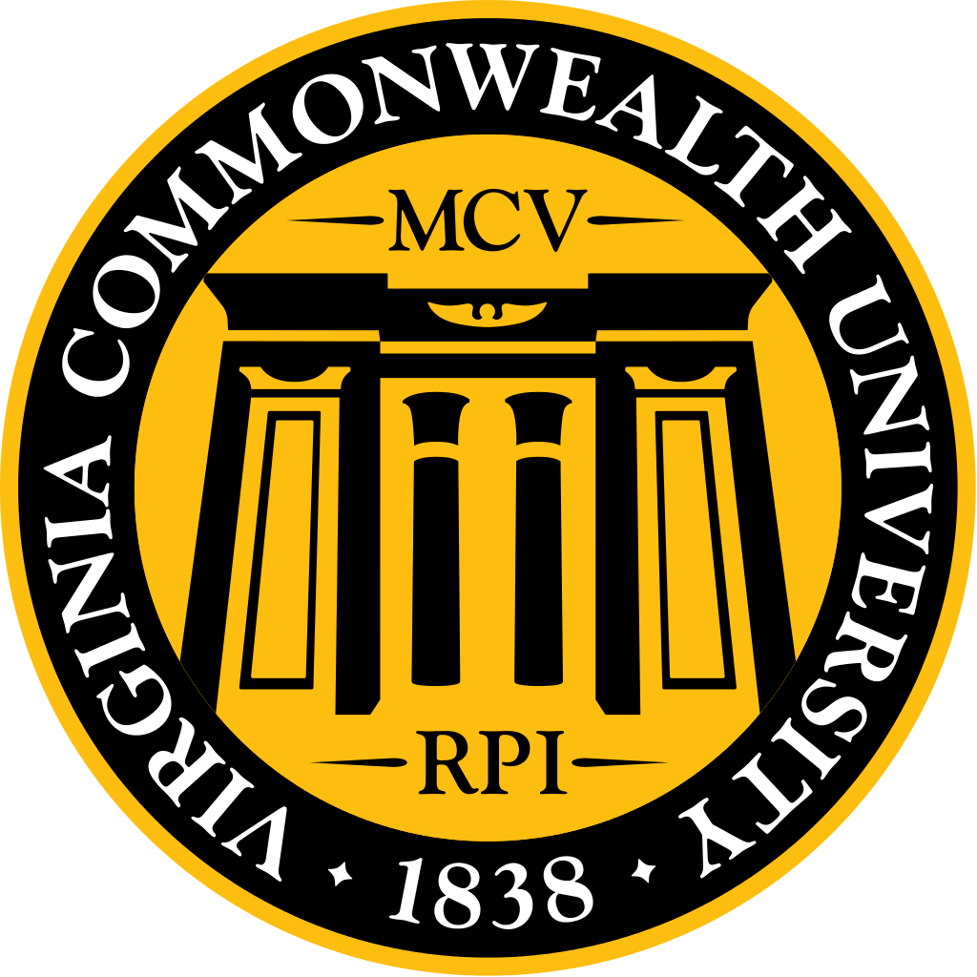
10.27.16 Dean’s Luncheon Minutes

Highlights
- The school is taking the security issues very seriously. Some changes have already occurred, such as increased security presence, but many more are to come. When they have the final recommendation they will come to MSG to talk to the student body about the changes before they are all implemented. It is also our responsibility to help keep the campus safe. If you notice the fire door is open between the hospital and MMEC after 6pm or on the weekend please close it and if you see anything suspicious contact VCU police.
- Ram safe will be coming to our campus in January! Until then please continue to use the MCV escort service for free safe transportation on campus. The Escort Service is available from 5pm – 8am daily at (804) 828-9255.
- M4s: If you contact the alumni association they can connect you with previous VCU grads who would be happy to host you! There is also a website called swap & snooze for free housing on the interview trail: http://www.swapandsnooze.com/
- The school takes mistreatment very seriously. Focus groups on mistreatment emails have gone out. Encourage students to report any mistreatment, because if we do not know then we cannot do anything about it! We will protect you & your identity.
- LCME survey is coming out soon. This survey is the final step of the accreditation process so please take the time to fill it out!

Outline
- Dean Strauss updates
- Dr. D updates
- MSG concerns
- Class of 2017 Concerns
- Class of 2018 Concerns
- Class of 2019 Concerns
- Class of 2020 Concerns
- Wine & Cheese feedback
- Mistreatment
- LCME survey
- Dr. Ryan update re HIPPA

A. Dean Strauss
- We take security very seriously and right now it is a concern.
- We will need to make some decisions so that staff and students feel comfortable and safe. When MMEC was built there was a talk to lock it down and have onsite security, since there was concern that people would wander into the building. We settled on key card access and decided not to disrupt the flow of the building with a security desk, especially since there are several entrances. We wanted the building to be open and accessible. 3 years later, this is the first time there has been significant security concerns. We will get this right. There will be some changes, but if there are any that will change your access we will be sure to get your opinions. We don’t want to disrupt the environment too much; we want easy access, but also safe.
- There are a lot of good potential changes coming, primarily through the health system. There is a major capital plan for new facilities for outpatient care. That will probably sit where the VTCC is. There are plans for two new bed towers, inpatient pediatrics and adult. It is an aggressive 7-year plan and has not been phased yet. Some of you may be here when these changes come. These changes are needed because we are at max capacity, on diversion more than we would like, and it is only going to get worse, especially with the success of the pediatric pavilion. There have already been some changes: new Stony Point and Short Pump buildings. A lot of good new facilities coming that will benefit you! This is a 2.3 billion dollar investment, but we have a plan to execute.

B. Dr. D
- Security changes coming: Chief of security is looking at all the buildings. Sanger, KMSB, MMRB are becoming 24/7 swipe only. MMEC lower entrance will be 24/7 swipe. Moving the building manager that sits in kontos to sit in MMEC. Adding more security. Adding a fire door that closes on the west hospital entrance to MMEC for which students and faculty would have key card access. We already have 24/7 passive cameras, but the person stationed in the front of MMEC would have access to view the videos. Looking to make the bathrooms on the bottom floors that are high access swipe only. Looking into the stairwells and elevators to see if we can make them swipe only. Talking to fire marshal to see if that is okay. The motorized door to MMEC is a concern for piggy backing into the building. This door may not be one that can be opened after hours. When we get final recommendations will come to MSG and talk to students!
- Door between the hospital & MMEC has been better about being closed after 6pm and on weekends every since talking to security.
- Ram safe will be coming to our campus in January! This is door-to-door transport. Until then, there is transportation available on campus.
- Asked the security chief to look into lighting and to see if we can get more.
- The blue light at A lot is being addressed rapidly.
- Fees for students will not go up.
- Also we need to protect our own building! If you don’t recognize someone ask for their badge, don’t let them open. If the door between MMEC is open after 6pm or on the weekends just close it!
- Deans will send a communication to students about security.

C. MSG Concerns
- Reminder of our main forms of communication:
a. MSG website – http://www.vcumsg.org/
b. MSG weekly scoop (attached)
- Please join us for our upcoming events:
  - Society Halloween Party Tuesday October 25th 3:30 - 5:30 @ Egyptian plaza
  - Mini Day of Community Service (DOCS) – November 12th @ Lewis Ginter
  - Medicine Ball 12/2 @ The Omni
- Concerns:
  - In light of recent events, many are concerned about safety on campus.
    - Addressed by Dean Strauss and Dr. D.
  - We are excited to have the opportunity to participate in the search for the new Dean through luncheons and tours, however we would have appreciated a little more of a heads up so that we could ensure that we could attend.
    - Agreed. No one got much of a heads up.
  - With the changes to the VCU brand we are concerned about what will go on the white coats and we hope that the seal will continue to be on the coat sleeve.
    - Deferred. Will follow-up with Deans.
D. Class of 2017 Concerns
- Concerned that the Dean’s letter does not include M4 evaluations, which is often when we are peaking in our skills. It is not always possible to ask for a letter of recommendations, especially since we are limited in how many we can submit. Many feel it would be beneficial to incorporate key phrases from our M4 evaluations. One suggestion was made to quote a good M4 evaluation in the dean’s letter and then state that they agree.
  - MSPE is a standardized letter. The AAMC says no and that it may only be M3 evaluations. Wouldn’t be fair for other schools.
  - Next year the MSPE is changing. Since so many schools have changed to an earlier M4 experience, they are allowing M4 experiences to go on the MSPE. September 1st will be the cutoff, only evaluations done before will be included. There is no cherry picking; if it is negative it will still go on. Only thing that could be added after September would be a professionalism concern. Mid November will get a list of changes to the MSPE.
- In light of recent events, many students are concerned as to what permanent measures are being taken to ensure the safety of students and faculty in MMEC. Some suggestions made by students include security patrolling the building as is done in the dental and pharmacy school, 24/7 badge requirement to enter the building, and having a security guard stationed at the front of MMEC.
  - Address by Dr. D and Dean Strauss at the beginning.
- Concerned that M4 loans are not sufficient to cover the costs of M4 year as well as the transition to residency, since we do not receive money after May and do not have an income until July or so.
  - Addressed by Dr. D and Pemra Cetin.
  - Not legally allowed to account for the transition into residency in loans. But we do include the increase in transportation for M4s. It is drastically more for that reason. There is about $4000 cushion in case you need it.
  - There are loans called residency relocation loans that may be helpful for students moving as a family. You may get a good interest rate, it is offered by a few loaners. It increases your borrowing so we do not recommend unless necessary. They range from $1000 – 20,000. Come to the Financial Aid office if you have questions about this, would be happy to talk to you more!
  - We are looking into ways, through endowment, that we can help students pay for this process. We know it is expensive.
  - Encourage you to contact alumni association who will connect you with previous VCU grads who would be happy to host you!
  - Website for M4s on the interview trail: http://www.swapandsnooze.com/

E. Class of 2018 Concerns - None submitted.

F. Class of 2019 Concerns
- There is a large concern amongst the students about the lack of study spaces within our own building, especially due to IPEC. Recently IPEC started using the side rooms as well as the studios. Students feel as though their only study spaces are being used and without any warning. They understand the use of the studios since they are designed for group learning, but if IPEC needs smaller rooms, are there other spaces in other schools on campus that could be used so that medical student study spaces aren’t the only spaces getting used? They are also concerned that it seems other students are not informed of the rules of the studios-i.e. no eating/closed containers only, quiet study spaces after classes.
  - The Dean’s did not know that she was going to take the small rooms. They have been contacted and informed that they should not be using our small rooms in addition to using our studio. They know now that they cannot do this, this will not happen again.
  - They have been told the rules of the building. Dr. D will again ensure that they are aware and enforcing the rules.
- Given the huge variability in preceptor expectations and PCM small group leader expectations, would it be possible to place greater emphasis on the SP workshop notes and make the preceptor notes P/F with comments? It is exceedingly difficult to write a PCM style note for a patient in a non-acute setting (i.e. In-patient Medicine, Transplant Surgery, etc.), especially when the preceptor and PCM small group leader often have very different expectations for the notes.
  - Will discuss this issue during the focus group. This has not been an issue in the past. PCM leaders have been told that preceptor notes should be graded more liberally. Considering making these notes pass/fail.
- Is it possible to limit the amount of time in lecture given to answering questions? Using e-board or asking questions after the session could be re-emphasized to the students in order to ensure lecturers have enough time to cover all the material sufficiently.
  - We have had this question before. At the next course directors we can suggest to faculty that when questions are getting dragged out to cut them off and ask students to ask after class. Do not want no questions, since often questions asked benefit all students.
G. Class of 2020 Concerns
Test review improvement – would it be possible for the curriculum representatives to meet with the course director after the exam to discuss student concerns about the test. These concerns could be collected via google form asking:
  - What problem on the test the student wants to bring to the course director’s attention?
  - Explanation of confusion
  - Citation of information from the lectures that leads to this students’ reasoning
This may lessen the amount of student questions that occur at the test reviews and would eliminate the same question being asked multiple times. It would also allow all students to hear the explanations of these questions, which would be beneficial to everyone.
- We cannot do that because of the security of the exam. If we start doing this the questions will get out. We do not accept challenges to questions. We have an item analysis and it is usually really good. When curriculum reps or other students point out a problem we are responsive. With the situation with pharm, that was handled and students got points. We re use questions so for the integrity of the exam unfortunately we can not do this.

H. Wine & Cheese Event Feedback
- Many faculty members have come up to Dr. D and said what a great experience.
- 30 students and many faculty were present. Many faculty who could not make the event said that they wish they could and they would love to be involved in the future. Almost every field was represented.
- Well while event! Food was great.
- This event came in response to students voicing that they wish they had more contact with faculty. Plan to continue event!

I. Mistreatment Comments
- Dr. D: Focus groups on mistreatment have gone out. We take mistreatment very seriously. The main concern is that students are not reporting mistreatment. Talking to students to try and understand why students aren’t reporting, what barriers there are to reporting, and what you would like in place to make it easier to report. If we don’t hear what is happening then we cant prevent. We need some way to work it out; whether it is an app, button, a person, whatever it is we can put it in place, but we want to hear about these things! We will protect you and your identity, but we want to hear so that we can stop it. We would not hold the person up, but would hold the event up so that people know that we take these things very seriously and that way people will hopefully think twice before saying or doing things.
- Dean Strauss: Graduation questionnaire showed a spike in mistreatment. We need to have a reporting system that everyone feels comfortable using, because if we don’t know then we end up contaminating our learning environment. Wonderful studies have looked at the quality of learning environment and one article showed the learning environment translating into quality of care. If you are afraid to interact or ask a question, then your learning curve is diminished. We need to take this on in an aggressive fashion. Not just because of AAMC, but also to make VCU the best learning environment we can!
J. LCME Survey
- Plan to give students two weeks to complete the survey. The dean’s would like to add a couple questions: would like to know which departments are involved in mistreatment. We need a holistic approach to mistreatment, but if there are hot spots then we can take a prophylactic approach.

K. Dr. Ryan, HIPPA update
- There has been a HIPPA issue. Reminder to all students to respect patient privacy.

