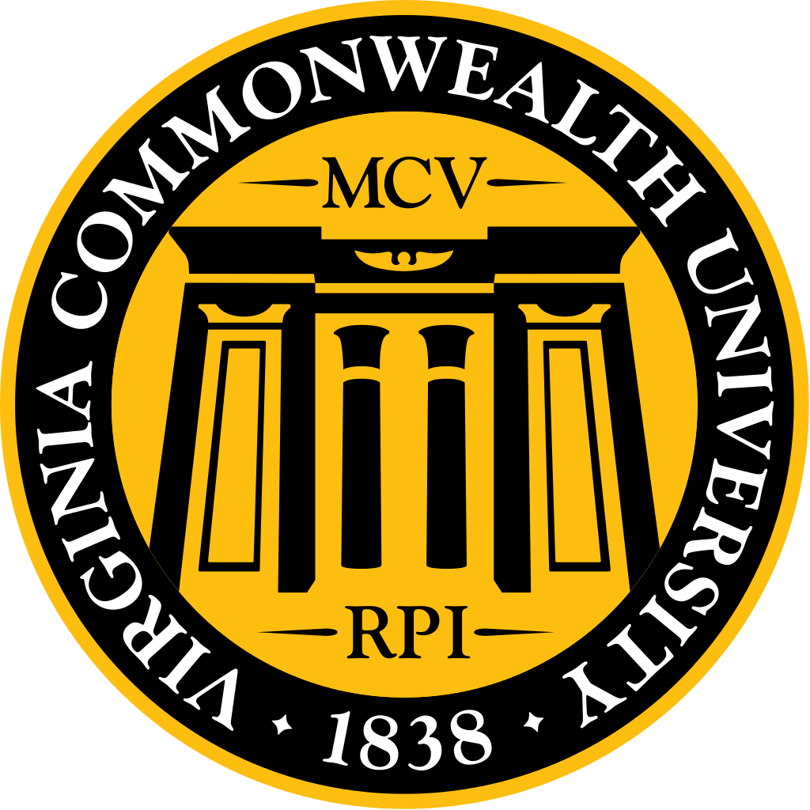
October 2016 MSG Agenda

Highlights:
- Working hard to increase security and make students feel safer in MMEC. Things being looked into: 24/7 key card access for all entrances, moving the security desk to MMEC lobby, someone monitoring the cameras 24/7, have security do safety checks on a regular basis, lights not dim in restrooms. Adding more lighting and increased security present to A lot.
- New ecurriculum updates, bar at the top no longer magnifies! See the msg website for detailed list of updates.
- VCU is moving toward one SGA for all VCU Richmond students, see powerpoint for details and email Keith Zirkle zirklekw@mymail.vcu.edu if you have any questions, feedback or would like to be added to the email list.
- Curriculum reps have had their voting rights restored at curriculum council meetings
- M1s: start thinking about your Halloween costume in preparation for the annual Halloween costume contest!
- M2 are leaving us soon. Please ask around or know anyone that would be great please encourage them and have them contact either the M2 or Katie Pumphery!
- Important dates:
  - Medicine Ball – December 2nd
  - Halloween Party – Tuesday October 25th 3:30-5:30! Same activities as last year. Cookie decorations, costume contest, photo booth, pumpkin painting!
  - Thanksgiving Food Drive – 11/01-11/15. Still based on societies.
  - November mini-DOCS – November 12th, Lewis Ginter Botanical Garden
  - Holiday Party – Friday December 9th. Announcement coming soon!
  - Study breaks – December 6th and 7th
  - Winter ball – January 28th at Omni.
  - Strauss Cup – Sunday April 30th. Working to find different location. Any suggestions welcome!

Welcome & Introductions (5 min)
- Ms. Kendal Plagueman, VCU Assistant Dean of Student Affairs
  - Thank you for having me!
  - Her office on MCV campus is on the second floor of Hunton.
- Dr. Woleben, security update
  - We are reviewing all of your surveys!
  - VCU security has been very supportive of the discussion
MMEC:
  - Looking into 24hour key card access and why the door on the bridge doesn’t get shut. Adding a card swipe to the entrance to west hospital to make that entrance safer.
  - Considering having the security desk relocated to lobby of MMEC 24/7. VCU police does not have it in their budget so this would be at a cost to School of Medicine. The Dean is on board.
  - Dental school has hired security that does safely checks on a regular bases, so hopefully we can have something like this.
  - There have been lots of questions for card access on each floor, but we have to think about fire codes. Looking into what types of locks we can put in order to ensure that we are not violating any codes.
  - There have been concerns about lighting in the bathroom. Since MMEC is a LEED Silver certified building many lights are dimmed at times, but we are looking into how we can have lights always on in restrooms.
  - There have been questions about adding cameras to the building, but we already have cameras. Currently there are 12 cameras in different areas, all the entrances. These are passively monitored. This means they are not monitored 24/7, but when an incident happens we can look back at them. These are what helped pin down the person in the incident last week. If we were to move the security desk to the MMEC lobby then there could be someone monitoring the cameras.
  - 6pm – 1 or 2am seems to be the max hours of use of MMEC. Looking to having security in the building at least for this time.
A Lot:
  - Increasing lighting, re angling existing lights, and increased presence of security.
  - Working on lighting of Broad Street! Will try and make sure that the lights are maintained better, but this is mostly up to the city.
  - Looking into better marking for the cross walk. 95 to broad street west, already on the list of things to do for the city. Already added more flashing lights alerting of the cross walk!
  - Question: Will there be an increase in student fees? I hope not! Should come from the school for safety and should already be part of your student fees via rams connect.
  - Question: Has there been an increase in security presence? Yes! Most has been undercover so you may not have noticed.

Student Introductions

Class Updates (2 min per class)
- Class of 2017
  - Receiving residency interviews and some have already gone on interviews!
  - Continuing to get back Step 2 CK and CS scores, looking great!
- Class of 2018
  - At the end of this month will be half way done 3rd year!
- Class of 2018 - INOVA:
  - 1) Are doing the triathlon challenge. 2) Went to adventures rope course on Friday! 3) Planning holiday party!
- Class of 2019
  - We are in renal!
- Class of 2020
  - Recently there was a recording of Dr. Baumgarten and Dr. D having a convo about our class. We met with Dr. Woleben, Dr. D and Dr. Baumgarten and talked to them. After that conversation Dr. D sent an email and explained what expectations are as students and M1s. The M1 Officers are working to improve communication. M1 officers held their ground while not angering the deans too much, well handled!

New business (5-8 min per group) - Have something you want to discuss at a MSG meeting? Contact MSG and ask to be added to the ‘new business’ section!
- Keith Zirkle, Joint Student Government Council (JSGC)
  - Right now there are two separate SGAs, one for the Monroe campus and one for the MCV campus, but soon we will have one SGA that will oversee the entire VCU Richmond student body. The decision was made to make one joint government because the campuses have many of the same concerns. Combined there will be better communication between the campuses, there will be more funds and SGA will be more powerful. Will vote on one SGA spring 2017 (next semester).
  - Anticipate fees will increase.
  - See attached powerpoint for more details.
  - Email Keith Zirkle, zirklekw@mymail.vcu.edu if you have any questions, feedback or would like to be on the email list!
MSG Updates (5 min per officer)
- Treasurer
  - Official MSG Budget!
  - Just got official budget: $40,000 + $7000 left over. Trying to conserve. Our budget will go down to 35,000. 17,000 left.
  - Huge deal that we have these numbers, this is years in the making!
- VP of Social
  - Cheese & Chat - October 14th
    - Networking event, ton of interest!
  - Medicine Ball – December 2nd
    - Planned at the Omni. Booked DD bus. Will have a DJ & live band!
- VP of Community Service
  - DOCS Feedback – was successful! All locations had a good time. The kidney screening was supposed to be a really big thing, but only 9 people came. So that was a little disappointing, but for the most part everything worked out!
  - DOCS Liver Rounds Feedback – ran out of food, but went great! I think legends was good, nice area!
  - October mini-DOCS Feedback – kind of a disaster, but anticipated that. Was at Urban farm. It was raining, so most said not coming. Only 3 came, but there were people from other organizations so it was good. Ended up working in a greenhouse so didn’t have to work in the rain.
  - New student org idea – Sisters awareness. Pregnant or teen moms. Thinking to have a community of elementary schools.
  - Thanksgiving Food Drive – 11/01-11/15. Still based on societies. Will count every day. All food goes to feed more Virginia.
  - November mini-DOCS – November 12th at Lewis Ginter Botanical Garden, very pretty! Was successful last year. Many gardens and light up in holidays. Tell people to sign up!
- VP of Societies
  - Strauss Cup – Sunday April 30th. Working to find different location. Any suggestions welcome!
  - Halloween Party – Tuesday 25th of October 330-530! Same activities as last year. Cookie decorations, costume contest, photo booth, pumpkin
  - Holiday Party – Friday December 9th. Announcement coming up, look out for an email!
  - Annual M1 costume contest!
- VP of Student Life
  - RamsConnect Feedback: 17 responses from SIGs; 5 Registered, 12 Unregistered. Of the 5 Registered, none are certain they completed all requirements. The most-cited hurdle for both Registered and Unregistered groups was the 5hr leadership training on a Saturday. Most favorable time and location for training would be 12-1pm on MCV campus.
  - Security Concerns: 52 survey responses, 43 of which included written concerns. 52% of respondents would be satisfied with an email follow-up from administration, 38% of respondents request a Town Hall meeting.
    - Most common concerns:
      - Doors found propped open after-hours instead of being locked, particularly 2nd Fl breezeway to Main Hospital
      - Feeling unsafe inside building, particularly after-hours
    - Most common requests:
      - Limit public access with ID swipe, either whole building or particular floors
      - Security attendant to monitor in/out traffic, similar to Sanger
  - Question: Regulations for SIG Fundraisers involving foodstuffs: do we have any parameters for SIGs who want to do a food-based fundraiser? Space/wording/approval? No there is not!
  - Let your classmates that we do respond to feedback, so please give it!
- VP of Publications
  - Website
    - Had first tech meeting, each class represented!
    - Gathered concerns and brought them up to Dr. D and the folks in charge of ecurriculum. There were similar concerns to the past. M3s had video conference concerns. Modifying echo and looking into potential new platform. HUGE victory: roll over no longer magnifies! Another update coming soon. It sounds like Eboard is going okay. Will post on the website a detailed list of updates.
- VP of Curriculum
  - The meeting with new and current curriculum reps went very well. Thanks to all who participated. Experienced curriculum reps shared their wisdom in interacting with faculty, fielding concerns from classmates, and overall expectations for their role as curriculum reps.
  - M2 CRs planned on having a follow-up meeting with the M1s to discuss the finer details of CR responsibilities.
  - Per Drs. DiGiovanni and Chelmow, CRs have had their voting rights restored. Each class is allowed 1 vote per curriculum council meeting. Curriculum representatives are expected to cast their votes on behalf of their class as a whole.
  - Currently working on assembling a follow-up survey for per LCME monitoring requirements outlined in their response to the survey visit last spring.
    - Our suggestions have been emailed to Dr. D and Dr. Woleben.
  - A few curriculum reps expressed interest in assisting with the survey. Once we have clear roles, we will reach out to them to elicit their help.
  - Eboard still the main way for feedback and in person conversations.
  - Q: how should requests be made that students don’t want to share with administrators? Ebaord can be used by administration, but they don’t go there looking, but still not annonymous. Can email them or talk to them in person. Reps are good at staying discrete. May need a better google forum to keep things annonymous, if that is something people want.
- Secretary
  - Dean’s Luncheon – October 27th
  - Next MSG Meeting – November 9th, MMEC 3-101 at 6:30 PM
    - VCU marketing, trademarks, and licensing will be attending to talk with us about the VCU brand, how we can use it correctly and the process to receive approval.
  - Spring dates being confirmed
- MSG rep to SGA
  - Has $0, started with $40,000.
  - Winter ball January 28th at Omni. All know so far.
  - Study breaks December 6th and 7th.
- President
  - Joint Student Government Council
  - RamsConnect Updates
    - Minimum of 8 students
    - Delay registration date (ex. October 1st)
    - Eliminate fall and spring orientation
    - Eliminate Lunch’N’Lead requirements
    - No current finance training required
  - Security Meeting Follow-up – Dr. Woleben spoke at beginning of meeting.
  - Considering doing an event at a restaurant in Richmond and having some of the proceeds go toward each class.
  - New Dean’s Luncheon - MSG will send 4 people.
  - M2 are leaving us soon. Please ask around or know anyone that would be great please encourage them and have them contact either the M2 or Katie Pumphery!

