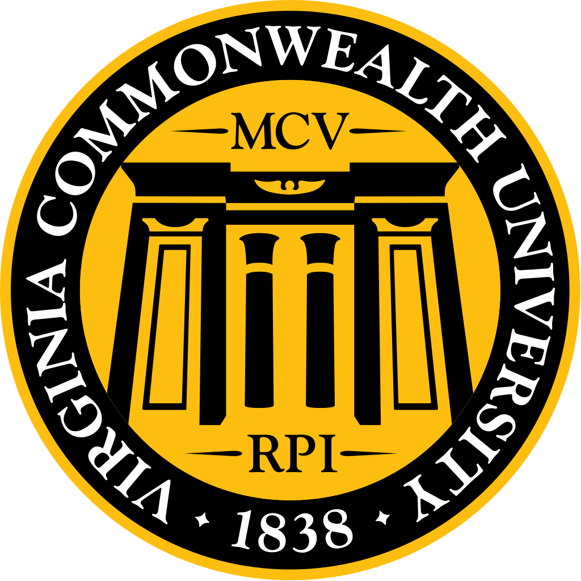
January 2017 MSG Agenda

Welcome & Introductions

Highlights:
  - The school takes mistreatment seriously and is working to improve reporting. Currently working on an online reporting system, which the School of Medicine will pilot. We want to streamline the process and make reporting easy to encourage students to report early.
  - Health campus wide campaign to promote safety and respect, reach out if you would like to be involved!
  - If you haven’t already, please fill out the LCME survey!
  - Looking into how we can improve attendance and involvement at events, especially DOCS.
  - Joint Student Government table at Larick to answer questions about the merger, January 23rd
  - MCV Winter Ball, Saturday, January 28th, tickets still available!
  - January mini-DOCS, Saturday, January 28th, Bark VA shelter
  - Health Sciences Students & Faculty Volleyball Tournament, February 25th, more details to come!
  - Match Day is open to the entire school, Friday, March 17th!
  - Wellness Block Party, Saturday, March 18th, 1-4pm, visit healthfairvcu.org and reach out if you would like to be involved!
  - Strauss Cup, April 30th
  - Next MSG meeting, February 25th, will be all about getting to know Dean Buckley!
  - Class of 2017: ongoing community service project to collect complimentary toiletries to donate to local homeless shelter. Collection box in curriculum office. Finishing up interviews and getting excited for match day/takeoffs/graduation!
  - Class of 2018: Turning in preferences for AIs and scheduling step 2. Talked to the deans about the mistreatment button not working. INOVA: many completed the athletic challenge!
  - Class of 2019: officially started board prep!
  - Class of 2020: On marrow & movement, going well, students are happy! Got gloves with MSG money for anatomy.
  - See minutes for more details.

Speaker/new business (5-8 min)
- Ms. Kendal Plageman – VCU Assistant Dean of Student Affairs
  - Monday, January 23rd, Joint Student Government table at Larrick to answer any questions you may have about the student government merger
  - Winter Ball Saturday, January 28th at the Richmond Omni Hotel, tickets still available
  - Wellness block party at MLK middle school, Saturday, March 18th, 1-4pm, organized by Allied health, but looking for connections and ways to reach out. Visit healthfairvcu.org for more information and reach out if you would like be involved!
  - Blood drive tomorrow (1/18/17) in Larrick, 11-7pm in honor of MLK jr.
  - Student affairs is aware of reports of interactions between faculty and students in the school of medicine, though not unique to the school of medicine. Working with administration on an online reporting system that will likely go to the deans office in hopes of encouraging students to come forward early. There will be an option to report anonymously. Will be working with Katie and MSG to get early feedback. Would like to pilot thru school of medicine, but then will be open to all health schools. Currently running a campaign to promote respect. Reach out if you would like to be involved.
- Dr. Alena Hampton – VCU Director, Student Experience
  - Pleased to be back!
  - New initiative: It is important to Dr. Rapley, the VP health science, to provide world class experience for our students. One thing is to ensure that we have the opportunity to interact with faculty and professors in non-academic setting. This initiative lead to the creation of a faculty and student volleyball tournament, Saturday February 25th!
    - Each school will have its own team, equally comprised of students and faculty. There will be a trophy! The VCU volleyball team will host a clinic prior to the event and there will be pizza!
    - If you do not want to play, please come out to cheer! We hope for this to be a packed event. Free concessions. Hope this is the first of many to come!
    - Great way to interact with the faculty without the fear of evaluation. Teams will have a limit of 12. 6 faculty and 6 staff.
    - Be on the look out for twitter. People may be talking some smack!
    - MSG funding could cover t-shirts.
- Dr. DiGiovanni
- Would like to reiterate that we take mistreatment seriously and want to do anything we can to improve reporting. Working hard to cooperate with the other schools to hold a campaign campus wide to promote safety and respect.
- Would like to re-send the safety survey
- Question: How does INOVA handle mistreatment
- Answer from INOVA students: We have a card with options on how to report mistreatment, such as a confidential hotline and mistreatment website. We also receive monthly emails. We have a QR scanner for our phones to report. There is also a person that students can report mistreatment to that is not the deans office.
- Dr. D: We would always protect you if you came to us, but we understand your concerns and want you to feel absolutely comfortable reporting mistreatment and know that procedures will be followed to ensure that you are protected, that this doesn’t happen again, and that we would work with human resources to take action against the individual that mistreated the student. One example of mistreatment that was reported was someone throwing gloves and hitting the student, that is mistreatment. Another example that was reported was a student completing a discharge summary signed in as a resident. That is not mistreatment. That is medical fraud. That resident could lose their license. Looking into a quarterly report to faculty and students about things that have been reported. This report would include things that are mistreatment and what was done about it as well as things that are not necessarily mistreatment and what happened. We have to keep it generic, because you have to protect all involved individuals’ rights. At m3 orientation we will have video vignettes to help train on what is mistreatment and so you can know what you should report and how. At Walk to walk for interns they will also be getting mistreatment training for the first time.
- Ms. Plageman: There are many ways to report, but we are trying to stream line it and make it more simple and easier for students to report. What’s the best and neutral way and how can we encourage it and how we can make it simple and easy to students will report!

Class Updates (2 min per class)
- Class of 2017
  - Excited that many are back! December was military match, optho matched 2, urology in 2 days, and Match Day Friday, March 17th. More details to come! Ongoing community service project to collect complimentary toiletries and donate to our local homeless shelter. Box is in the curriculum office. M3/M4 panel tomorrow. Planning match day/takeoffs/graduation, exciting and scary!
- Class of 2018
  - Not much. Tomorrow turning in our preferences for AIs and scheduling. Scheduling Step 2 CK & CS. We talked to the deans about the mistreatment button not working.
- INOVA
  - Not much new. We had some people in our class complete the athletic challenge we sent out!
- Class of 2019
  - First day of board prep! We had a lovely 4 hours with Costanzo reviewing ~4 months of material. All in Step prep!
- Class of 2020
  - Currently on marrow & movement. Things are going well, it is organized and structured well. Nothing has gone wrong so students are happy! We got gloves from Costco!
  - MSG for the last 3 years has been giving money to students for gloves. This was started because most schools do get them paid for.

MSG Updates (5 min per officer)
- Treasurer
- Spring budget available per request
- If you would like to see the
- Deans Fund
- VP of Social
- January Liver Rounds – Recap
- Over 130 M1-M4 students attended
- Food was a little problematic, increased the amount of food during the event, spent $1600.
- February Liver Rounds
- Budget is $1000
- Date is TBD
- Brewery option, likely Garden Grove
- April looking into somewhere with some outdoors
- VP of Community Service
- January mini-DOCS
  - Saturday the 28th, Bark VA shelter, 10 spots, 20+ RSVPd.
  - Will narrow down.
  - Will have pizza
- February mini-DOCS
  - 25th or 18th – partner with MHA possibly, hasn’t responded much. May just schedule a normal one. Hands on RVA.
  - In the past there has been a conscious effort to get you into the community on a non-medical project, as a reminder that there is more than medicine.
- Partnering with other professional schools.
- Looking for methods to improve attendance
  - February. Google forum. Trying to get ideas as to why students haven’t been showing up.
  - More emphasis onto the student interest groups. Maybe tying into the SIG awards. Prize for people who attend all.
  - They are looking for more awards for student honors day, to make it more student centric.
- Is there a list of people of people who are doing community service?
  - Not now, but something to look into!
- Next dean’s luncheon – how can we give people credit!

- VP of Societies
- Winter social from last year was great!
- February event
- Proposed game board competition/game night. Will discuss at the society meeting.
- Strauss Cup updates
- April 30th
- Need to reserve $5000 from MSG
- Would appreciate any input as to what went well last year
  - Per MSG: interactive, signups, timed time slots, egg race, tug o war, water balloon toss.
- Planning to do a poll to see what people want!
- VP of Student Life
- Student Interest Group Information Session - Recap
  - Good turn out. Went over mostly funding. Guidelines of what they can and cant do with the money. Tim gave a great presentation!
- Health Fair Outreach
  - Would like to do a blurb about this in the scoop. Ever since allied health took this over, the medical school has not been as active, but would like to get more involved! Maybe getting student interest groups involved.
  - Hoping to start a list serve for student interest groups.
    - If anyone isn’t on the list, they should contact Erica.
- VP of Publications
- Student Interest Group Awards
- Winners: SNMA and EMSA
- Working on the booklet for the M3s
- Comment: Maybe we should have an actual physical booklet
- VP of Curriculum
- LCME Student Analysis Follow-up
- Dr. D: M1s & M2s have almost 300 responses. If you haven’t, please fill out!
- There is still an error with the website, but you can complete the survey even if you haven’t completed your clerkships. If you are having trouble, please let me (Jill) know and I will talk with Lelia. Please fill out the survey and spread the word!
- Secretary
- Spring dates – February 15th, March 13th, April 12th, May 4th
- Deans Luncheon dates - TBD
- MSG rep to SGA
- MCV Winterball
- January 28th at the Omni , next Saturday, if you haven’t, buy tickets
- SGA Meeting
- Next meeting January 25th at Larrick, free food
- They are merging our SGA and undergrad and joint committee and there are positions if anyone wants to run.
  - Q: Will SGA member still get paid? A: Not sure, will find out.
- President
- Dr. Buckley – February 15th MSG Meeting
  - Will be coming to the meeting. Will talk about who he is, what he’s interested in, and what future we want etc. Come have food and talk with Dr. Buckley. We will be emailing ahead of time a lot since no business will be covered during the meeting.
- VCU School of Medicine Second Look
  - March 25th. Needs volunteers. MSG will work with them.
- Class Officer and MSG – Defining roles
  - Share with your classmates about MSG.
  - Being involved pays off when applying for residency!
    - All M4s present at meeting agreed and all said they talked about MSG and their involvement at almost every interview.
  - Some things don’t pan out as well. Don’t want to re write the constitution, but would like expectations of how problems will be dealt with. Should we go to class officers first or straight to the administration? Would like it to be better described, with clear understanding between everyone. Possible hierarchy of how problems are dealt with. If you want to be involved, we want to use you! Will be talking to everyone about what we want and letting the faculty know. They say they’re on board with anything we want!
- MSG Lunch Lecture on Leadership
  - Thoughts on a one-hour session on leadership 101 with tips about things to do and not to do.
    - Consensus: great idea!

Attendance
Officer | Attendance/Proxy
MEDICAL STUDENT GOVERNMENT
President – Katie Pumphrey | X
Secretary – Perrin Downing | X
Treasurer – Suraj Mishra
VP of Student Life – Tim Wills | X
VP of Societies – Kathryn Gouthro | X proxy
VP of Community Service – Amanda Williams | X proxy
VP of Publications – Rajbir Chaggar
VP of Curriculum - Jill Safflinger | X
MSG Rep to SGA – Yousef Fazel | X proxy
VP of Social Affairs – Omar Protzuk | X proxy
CLASS OF 2017
President – Yeri Park | X
Vice President – Perrin Downing | X
Vice President – Karen Brown | X
Treasurer – Sarah Berg | X
Secretary – Fairouz Chibane
INOVA VP – Neil Patel
INOVA Secretary/Treasurer – Sri Karuturi
CLASS OF 2018
President – Trammell Cox
Vice President – Suraj Mishra
Vice President – Ron Rosenberg
Treasurer – Timothy Nobbee
Secretary – Soumya Murag | X
INOVA VP – Blair Saunders | X
INOVA Secretary/Treasurer – Ashley Rogers
CLASS OF 2019
President – Julie Park | X
Vice President – TJ Phillips
Vice President – Omar Protzuk
Treasurer – Jonathan Korpon
Secretary – Russel Dinh
CLASS OF 2020
President - | X
Vice President - | X
Vice President -
Treasurer -
Secretary -

